Chapter # 4 Data Analysis & Results
The objective of this report for making the thematic analysis that is truly part of qualitative methodology. Themes are matched with coding. In literature review part many themes and topic has been highlighted. Each theme contain a suitable title.

Source Summary
Title | Author | Date and Time | Length | Quotes #
Artificial Intelligence Usage For Sustainable Development In Education | Hassan(Thesis) | 17th July 2021 11:25 AM | 60423 | 27

Thematic Analysis Coding Summary
Main Themes Title | Parent | Grandparent | Description | Author | Date | Total Codes
Practical AI Application |  |  |  | Hassan(Thesis) | 17th July 2021 Time 11: 25 AM | 1
AI Business Model | Usages of AI in Teaching & Learning |  |  | Hassan(Thesis) | 17th July 2021 Time 11: 25 AM | 1
Education in china | Practical AI Application |  |  | Hassan(Thesis) | 17th July 2021 Time 11: 25 AM | 1
web based learning | Usages of AI in Teaching & Learning |  |  | Hassan(Thesis) | 17th July 2021 Time 11: 25 AM | 1
AI Based Collaborative based learning |  |  |  | Hassan(Thesis) | 17th July 2021 Time 11: 25 AM | 1
Virtual Learning Environment | AI Based Collaborative based learning |  |  | Hassan(Thesis) | 17th July 2021 Time 11: 25 AM | 2
Games in Education |  |  |  | Hassan(Thesis) | 17th July 2021 Time 11: 25 AM | 1
Usages of AI in Teaching & Learning |  |  |  | Hassan(Thesis) | 17th July 2021 Time 11: 25 AM | 1
Virtual Reality Environment | AI Based Collaborative based learning |  |  | Hassan(Thesis) | 17th July 2021 Time 11: 25 AM | 2
cognitive learning theories | Practical AI Application |  |  | Hassan(Thesis) | 17th July 2021 Time 11: 25 AM
E-Learning | AIED |  |  | Hassan(Thesis) | 17th July 2021 Time 11: 25 AM | 1
AIED |  |  |  | Hassan(Thesis) | 17th July 2021 Time 11: 25 AM | 2
Online Support Learning |  |  |  | Hassan(Thesis) | 17th July 2021 Time 11: 25 AM | 1
AI Teaching Assistant | AIED |  |  | Hassan(Thesis) | 17th July 2021 Time 11: 25 AM | 2
Data Mining | Computational thinking |  |  | Hassan(Thesis) | 17th July 2021 Time 11: 25 AM | 2
Computational thinking |  |  |  | Hassan(Thesis) | 17th July 2021 Time 11: 25 AM | 1
Entrepreneurship in Education | Computational thinking |  |  | Hassan(Thesis) | 17th July 2021 Time 11: 25 AM | 2
Distance Education | Online Support Learning |  |  | Hassan(Thesis) | 17th July 2021 Time 11: 25 AM | 1
AI Educational Robot | Practical AI Application |  |  | Hassan(Thesis) | 17th July 2021 Time 11: 25 AM | 1
Human Computer Interaction |  |  |  | Hassan(Thesis) | 17th July 2021 Time 11: 25 AM | 1
Natural Language Processing | Machine learning & Deep Learning |  |  | Hassan(Thesis) | 17th July 2021 Time 11: 25 AM | 1
Machine learning & Deep Learning |  |  |  | Hassan(Thesis) | 17th July 2021 Time 11: 25 AM | 1
TOTAL NUMBER OF CODES | 27
TOTAL NUMBER OF QUIRKS | 22

Properties Summary

Artificial intelligence

0% Education

0% 40

100% 5

Teacher

0% Teaching technique

0% 60

100% 10

Students

0% graduate

100% 28

Canvas - Primary
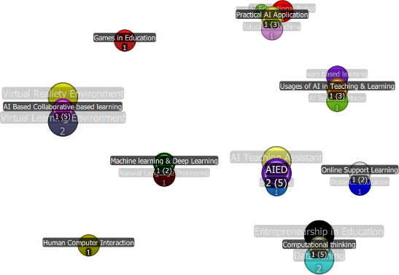
Figure 6: Themes View

Text Sorted by Theme

Practical AI Application
Introduces practical knowledge about artificial intelligence technique practices by the student it can be broader impact for developing sustainable AI technology. They deploy tangible object where student can built software using AI technology in the class room.
Source: Artificial intelligence usage for sustainable development in education

AI Business Model
it discussed the machine learning based approach for sustainable development of AI resources.
Source: Artificial intelligence usage for sustainable development in education

Education in china
Chinese Gov. established AI technology at education sector that rapidly development of AI technology based application.
Source: Artificial intelligence usage for sustainable development in education

Web based learning
Web based AI technology has been widely used by many researcher for promoting education and learners prospective.
Source: Artificial intelligence usage for sustainable development in education

AI Based Collaborative based learning
They uses mega cognitive tool which represent the state of interaction via the key indicator and coaching system
Source: Artificial intelligence usage for sustainable development in education

Virtual Learning Environment
personalization learning functions which have the possible to meet different requirements of different beginners to meet the different requirements of different learners to produce the e-Learning intelligent agents the virtual learning platform
Source: Artificial intelligence usage for sustainable development in education

They formulate the internal personalized learning mechanism to implement intelligent
Source: Artificial intelligence usage for sustainable development in education

Games in Education
serious games in education, most of the medical science student using serious games in education for practicing them the medical field system, this system was very useful for implementing the relationship in between the teachers &amp; student.
Source: Artificial intelligence usage for sustainable development in education

Usages of AI in Teaching & Learning
They suggest that recent artificial intelligence technology trends relate to adopting the new technologies over the period of time in order to predict the future nature of higher education in a world
Source: Artificial intelligence usage for sustainable development in education

Virtual Reality Environment
virtual reality environment for stimulating children’s imaginative writing for the development of student
Source: Artificial intelligence usage for sustainable development in education

The AI based framework used by the educational sector that relate to the student
Source: Artificial intelligence usage for sustainable development in education

E-Learning
E-Learning to improve the effectiveness of teaching and learning in exactness education.
Source: Artificial intelligence usage for sustainable development in education

AIED
It basic functionalities was to track the student attendance and collecting the assignment data from the students of all section. It was also works very well for speech gesture recognition
Source: Artificial intelligence usage for sustainable development in education

The application of artificial intelligence was very helpful for creating AI based model
Source: Artificial intelligence usage for sustainable development in education

Online Support Learning
AI agents might be used to support online student interaction, or simply contribute to the dialogues
Source: Artificial intelligence usage for sustainable development in education

AI Teaching Assistant
artificial teaching assistant capable of doing better than human teachers now thrive in leading institutes of learning that better environment as compare to the human
Source: Artificial intelligence usage for sustainable development in education

They improve the education teaching and learning standards using the AI technology
Source: Artificial intelligence usage for sustainable development in education

Data Mining
to store millions of information used by the universities of public sector as well as private sector.
Source: Artificial intelligence usage for sustainable development in education

intelligence (AI) dialogue was increased due to the rise of artificial intelligence education
Source: Artificial intelligence usage for sustainable development in education

Computational thinking
Perform computational thinking in K-12 grade class that required the systematic change, teacher engagement and development of significance resources should be related to significance education community to generate the vital effort in between the students and children community.
Source: Artificial intelligence usage for sustainable development in education

Entrepreneurship in Education
entrepreneurs can create the opportunity to involve the product and service design phase
Source: Artificial intelligence usage for sustainable development in education

Mostly all of the universities was collected information during the time of admission
Source: Artificial intelligence usage for sustainable development in education

Distance Education
Distance education was offer variety of freedom that relate the space time constrains, with increasing interactivity.
Source: Artificial intelligence usage for sustainable development in education

AI Educational Robot
Intelligent educational robot will be helpful for making teaching effective. These robots can be used at primary class level, which used to trained the student for effective English vocabulary learning
Source: Artificial intelligence usage for sustainable development in education

Human Computer Interaction
The model and simulation used to design the software engineering tools
Source: Artificial intelligence usage for sustainable development in education

Natural Language Processing
NLP enabled intelligent tutor systems. They suggest that these tutors was helps in developing qualities and self-reflection answering the deep question resolving conflict statement,
Source: Artificial intelligence usage for sustainable development in education

Machine learning & Deep Learning
Machine learning, Deep Learning, Neural Networks, big data that was new invention in Artificial Intelligence. Thinking critically and make analysis, take predictions, find outcomes and generate accurate results
Source: Artificial intelligence usage for sustainable development in education

Text Sorted by Source (Themes)

Artificial Intelligence Thesis
Introduces practical knowledge about artificial intelligence technique practices by the student it can be broader impact for developing sustainable AI technology. They deploy tangible object where student can built software using AI technology in the class room.
Theme 1: Practical AI Application

It discussed the machine learning based approach for sustainable development of AI resources.
Theme 2: AI Business Model

Chinese Gov. established AI technology at education sector that rapidly development of AI technology based application.
Theme 3: Education in china

Web based AI technology has been widely used by many researcher for promoting education and learners prospective.
Theme 4: web based learning

They uses mega cognitive tool which represent the state of interaction via the key indicator and coaching system
Theme 5: AI Based Collaborative based learning

personalization learning functions which have the possible to meet different requirements of different beginners to meet the different requirements of different learners to produce the e-Learning intelligent agents the virtual learning platform
Theme 6: Virtual Learning Environment

They formulate the internal personalized learning mechanism to implement intellectual.
Theme 7: Virtual Learning Environment

serious games in education, most of the medical science student using serious games in education for practicing them the medical field system, this system was very useful for implementing the relationship in between the teachers &amp; student.
Theme 8: Games in Education

They suggest that recent artificial intelligence technology trends relate to adopting the new technologies over the period of time in order to predict the future nature of higher education in a world
Theme 9: Usages of AI in Teaching & Learning

virtual reality environment for stimulating children’s imaginative writing for the development of student
Theme 10: Virtual Reality Environment

The AI based framework used by the educational sector that relate to the student
Theme 11: Virtual Reality Environment

E-Learning to improve the effectiveness of teaching and learning in exactness education.
Theme 12 : E-Learning

It basic functionalities was to track the student attendance and collecting the assignment data from the students of all section. It was also works very well for speech gesture recognition
Theme 13: AIED

The application of artificial intelligence was very helpful for creating AI based application.
Theme 14: AIED

AI agents might be used to support online student interaction, or simply contribute to the dialogues
Theme 15: Online Support Learning

artificial teaching assistant capable of doing better than human teachers now thrive in leading institutes of learning that better environment as compare to the human
Theme 16: AI Teaching Assistant

They improve the education teaching and learning standards using the AI technology
Theme 17: AI Teaching Assistant

To store millions of information used by the universities of public sector as well as private sector.
Theme 18: Data Mining

intelligence (AI) dialogue was increased due to the rise of artificial intelligence education
Theme 19: Data Mining

Perform computational thinking in K-12 grade class that required the systematic change, teacher engagement and development of significance resources should be related to significance education community to generate the vital effort in between the students and children community.
Theme 20: Computational thinking

entrepreneurs can create the opportunity to involve the product and service design phase
Theme 21: Entrepreneurship in Education

Mostly all of the universities was collected information during the time of admission
Theme 22: Entrepreneurship in Education

Distance education was offer variety of freedom that relate the space time constrains, with increasing interactivity.
Theme 23: Distance Education

Intelligent educational robot will be helpful for making teaching effective. These robots can be used at primary class level, which used to trained the student for effective English vocabulary learning
Theme 24: AI Educational Robot

The model and simulation used to design the software engineering tools
Theme 25: Human Computer Interaction

NLP enabled intelligent tutor systems. They suggest that these tutors was helps in developing qualities and self-reflection answering the deep question resolving conflict statement,
Theme 26: Natural Language Processing

Machine learning, Deep Learning, Neural Networks, big data that was new invention in Artificial Intelligence. Thinking critically and make analysis, take predictions, find outcomes and generate accurate results
Theme 27: Machine learning & Deep Learning

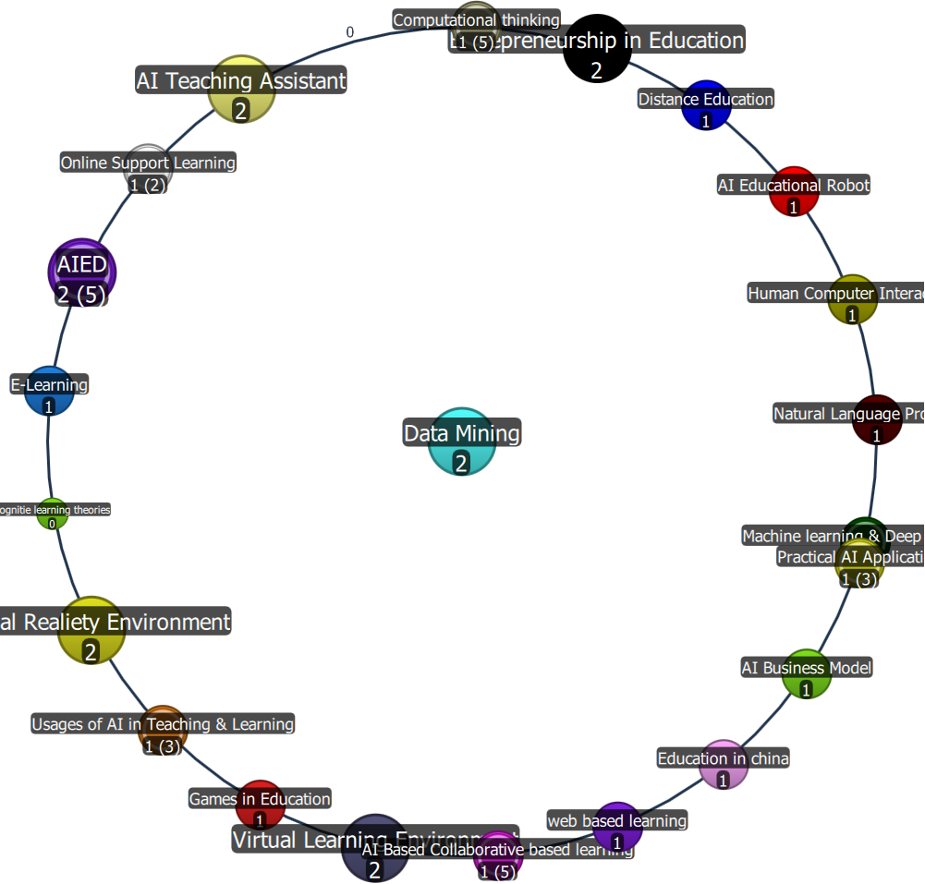
Figure 7: AI Useful technique to collect everything in one platform

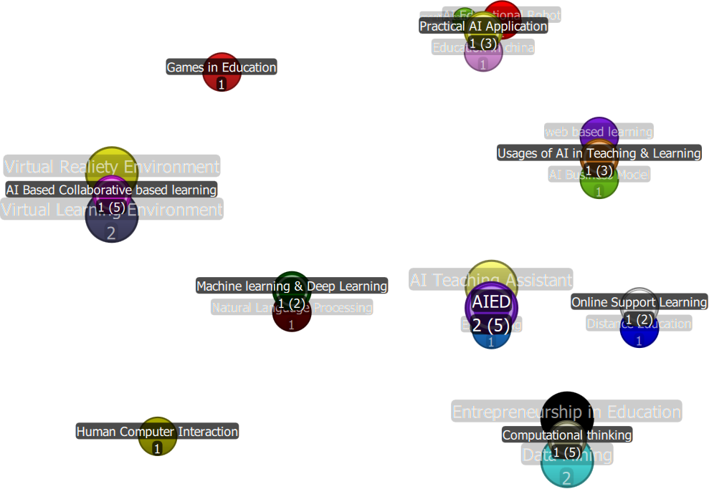

Figure 8: Computation views of Themes (Thematic analysis Image)
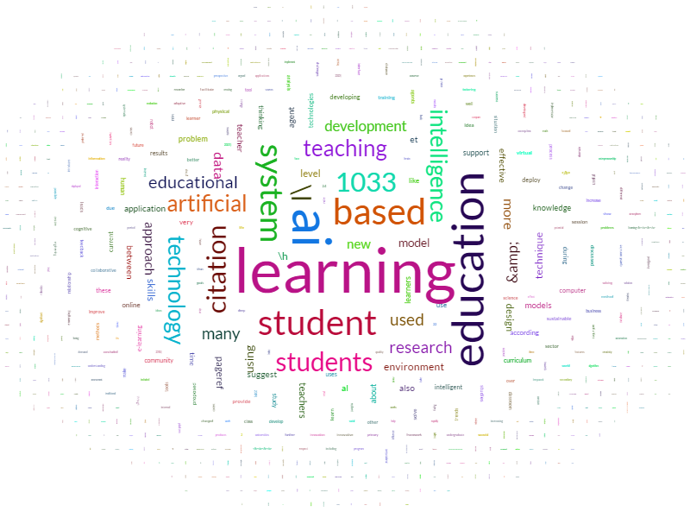
Figure 9: Circle view of Themes

